Image Processing Assignment Results

Index Number: 249337B Name: Paramanathan Thushanthan

# Question 1 : [Code for q1](https://github.com/harithushan/intensity_transformations_and_neighborhood_filtering/blob/main/q1.py)

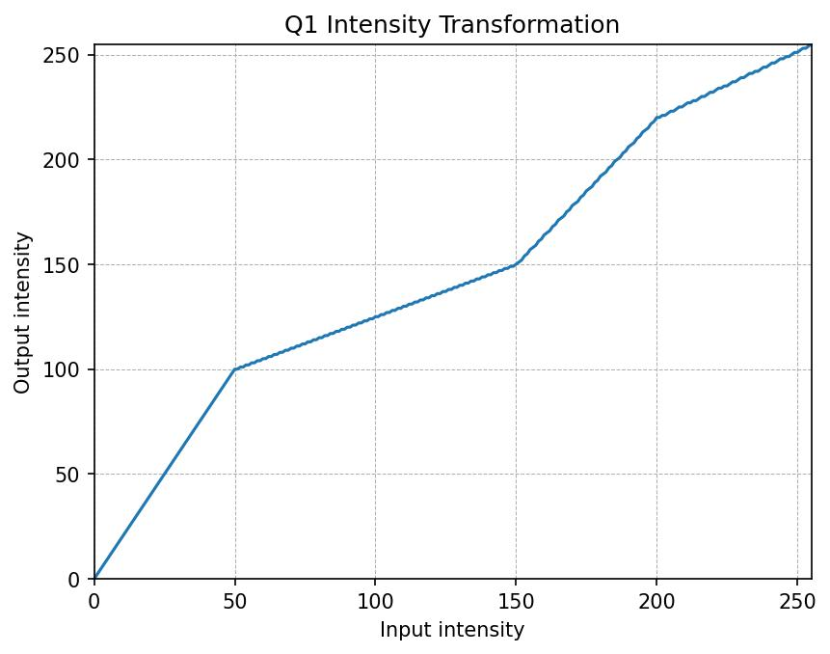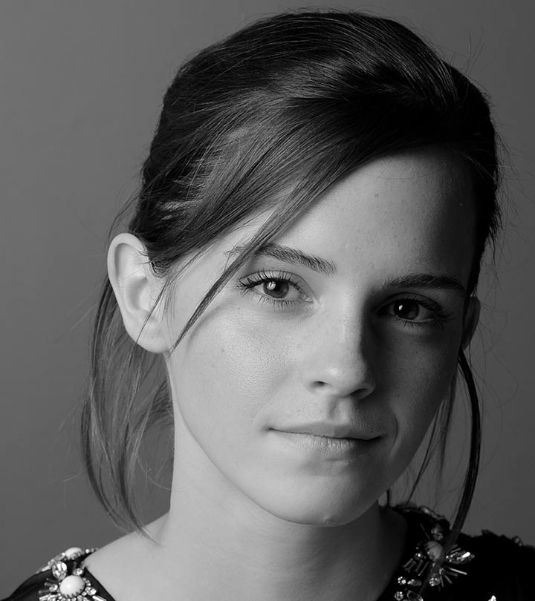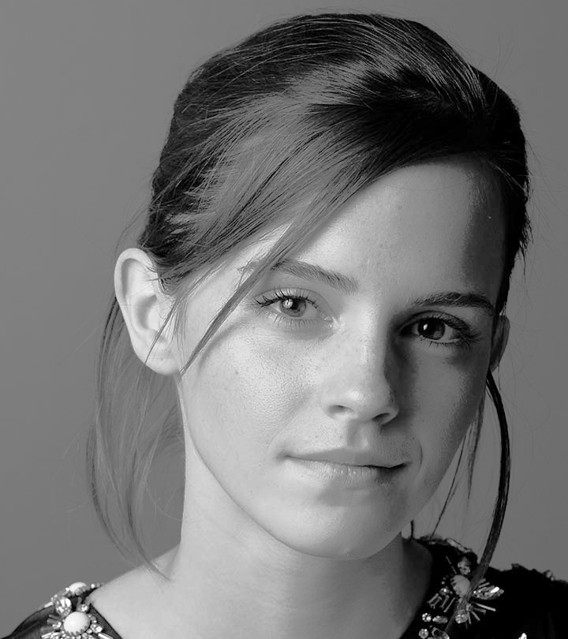 **emma_intensity_transformation**

**emma_original** **emma_mapped**

# Question 2: [Code for q2](https://github.com/harithushan/intensity_transformations_and_neighborhood_filtering/blob/main/q2.py)

**q2_original 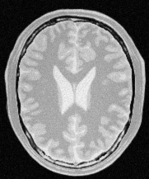 q2_histogram 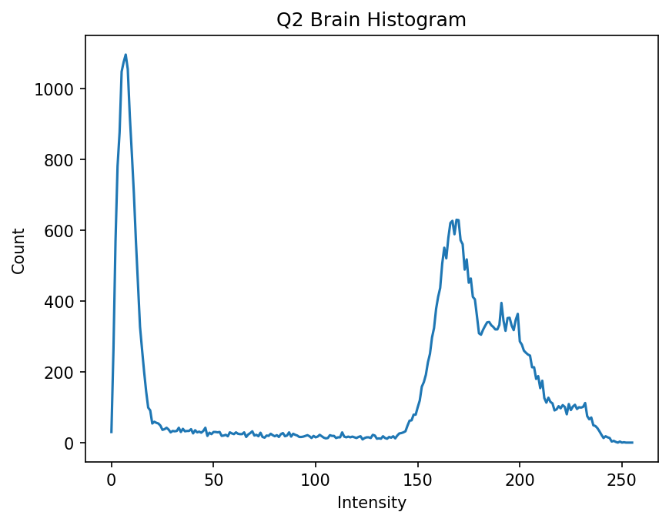 _**

**q2_gray_matter 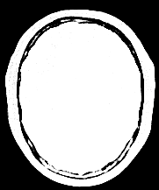 q2_gm_transfer** 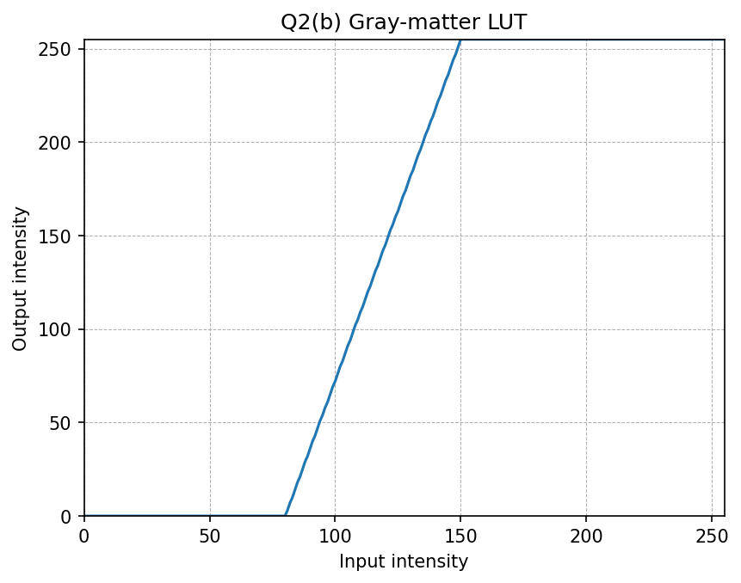

**qq2_white_matter 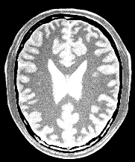 q2_wm_transfer** 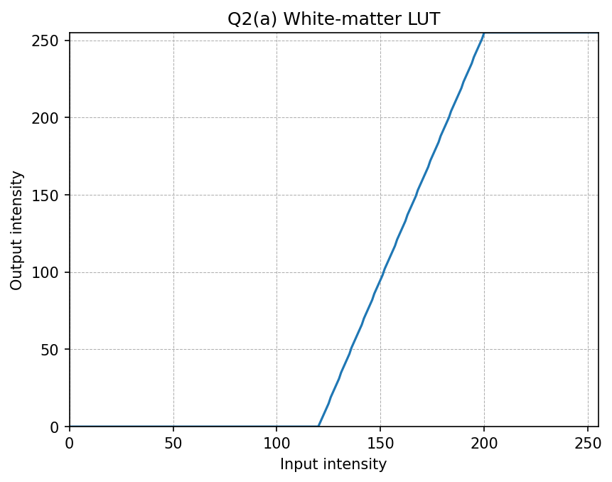

# Question 3: [Code for q3](https://github.com/harithushan/intensity_transformations_and_neighborhood_filtering/blob/main/q3.py)

**q3_gamma 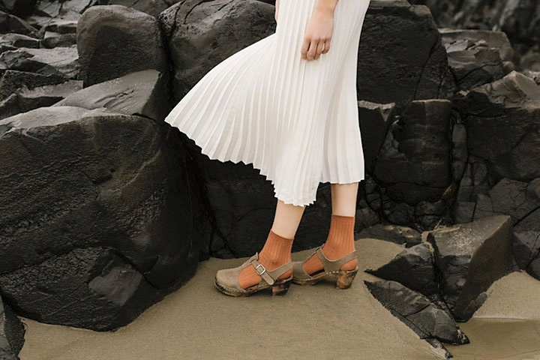 q3_hist_gamma** 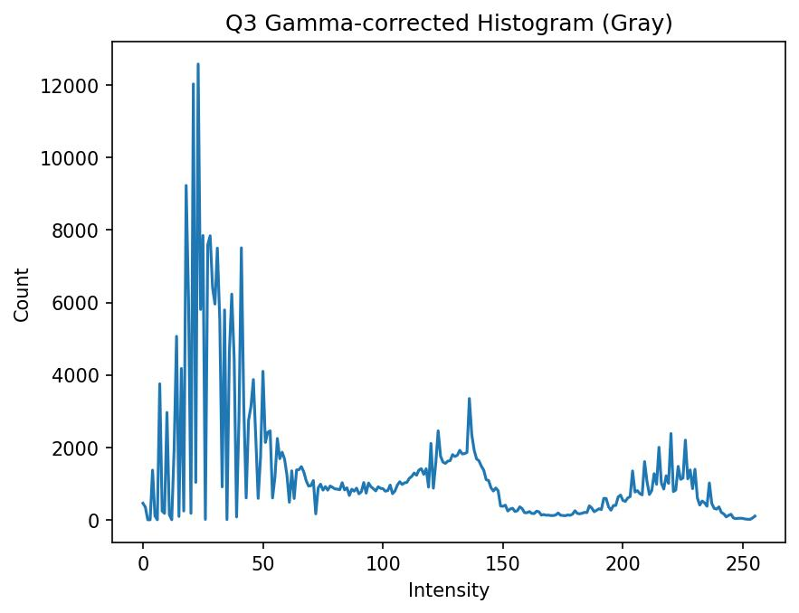

**q3_original 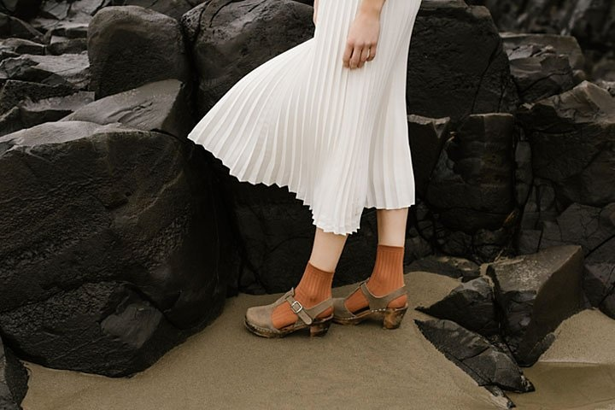 q3_hist_orig** 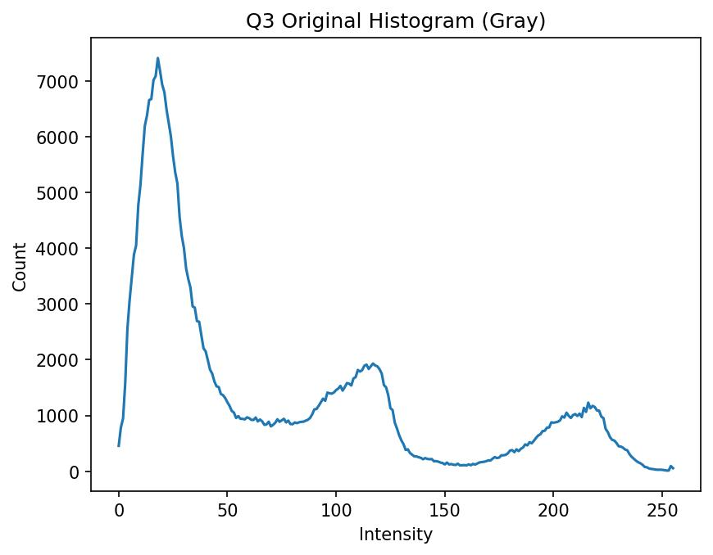

# Question 4: [Code for q4](https://github.com/harithushan/intensity_transformations_and_neighborhood_filtering/blob/main/q4.py)

**q4_spider_original 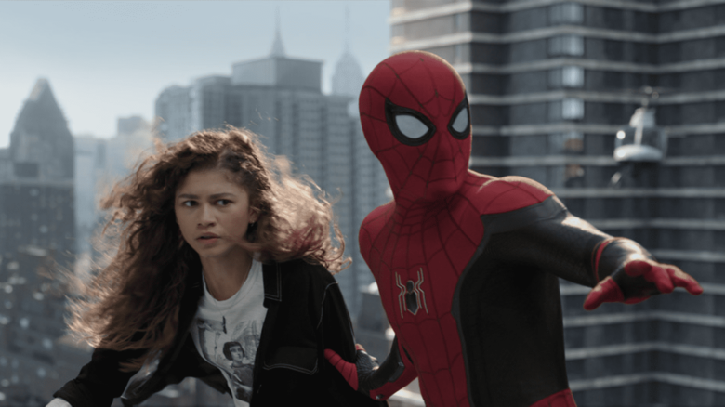 q4_spider_h** 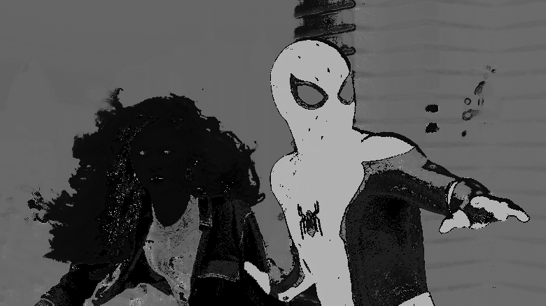

**q4_spider_s 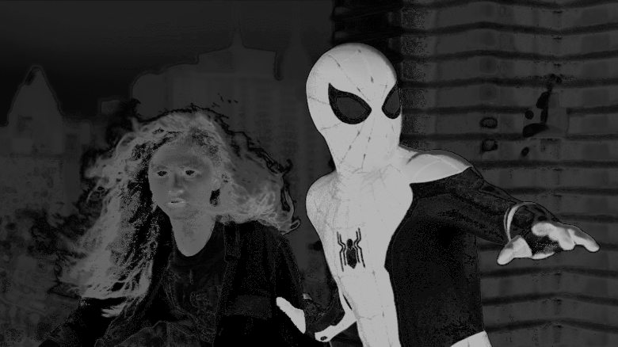 q4_spider_v** 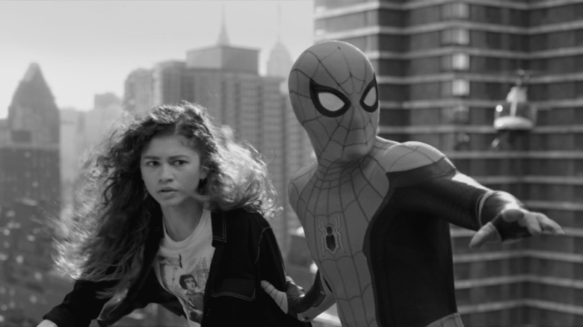

**q4_spider_vibrance 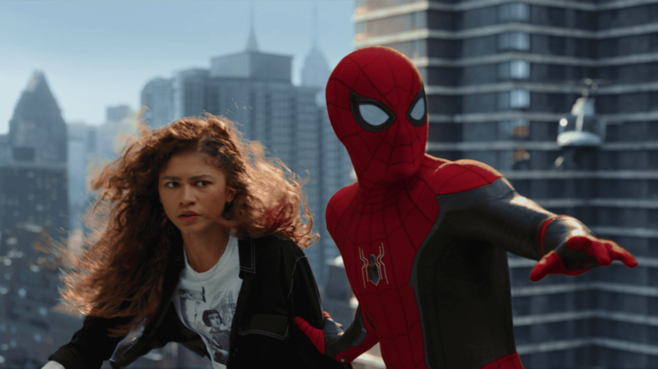 q4_spider_transfer** 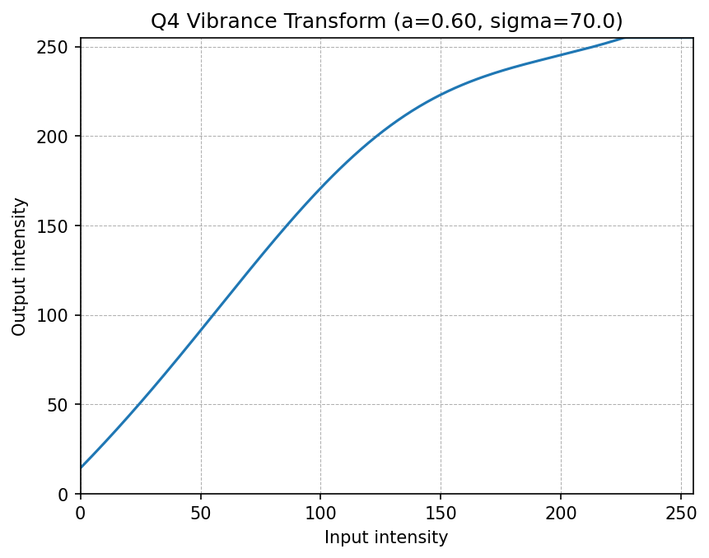

# Question 5: [Code for q5](https://github.com/harithushan/intensity_transformations_and_neighborhood_filtering/blob/main/q5.py)

**q5_original 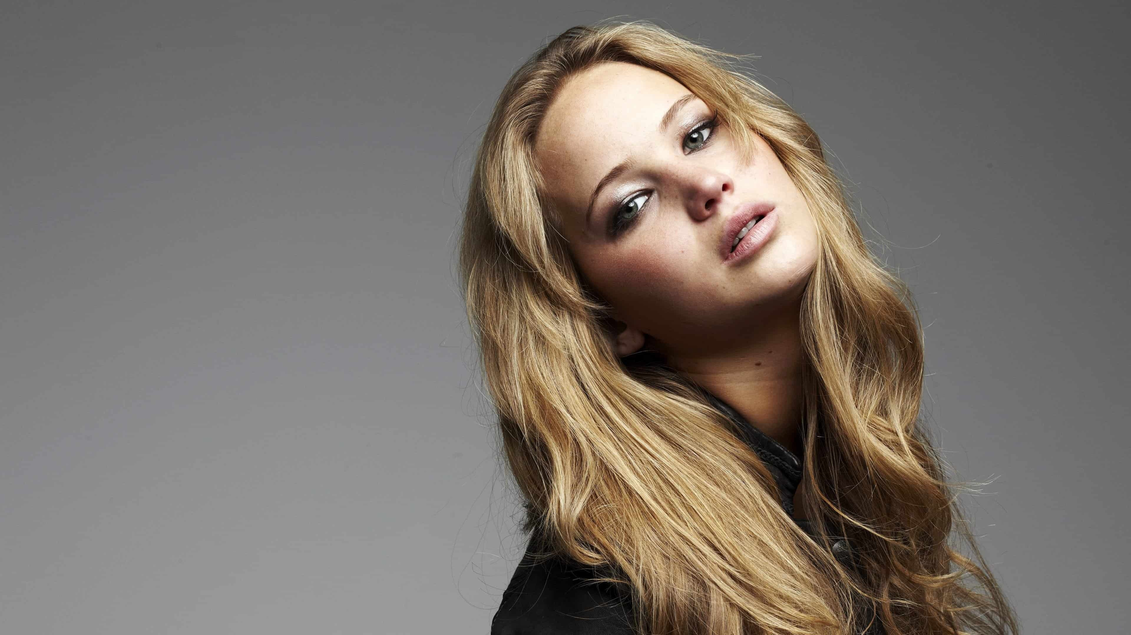 q5_h** 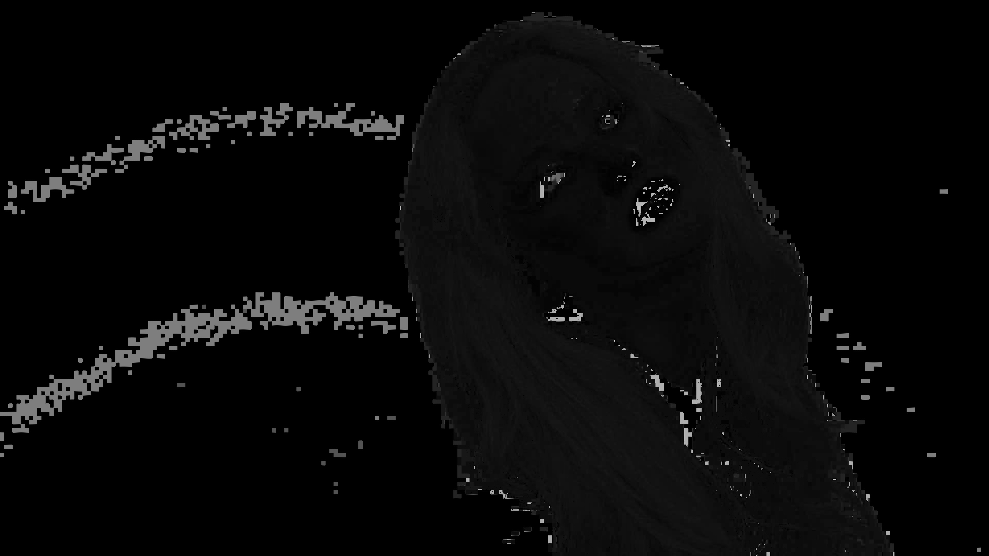

**q5_s 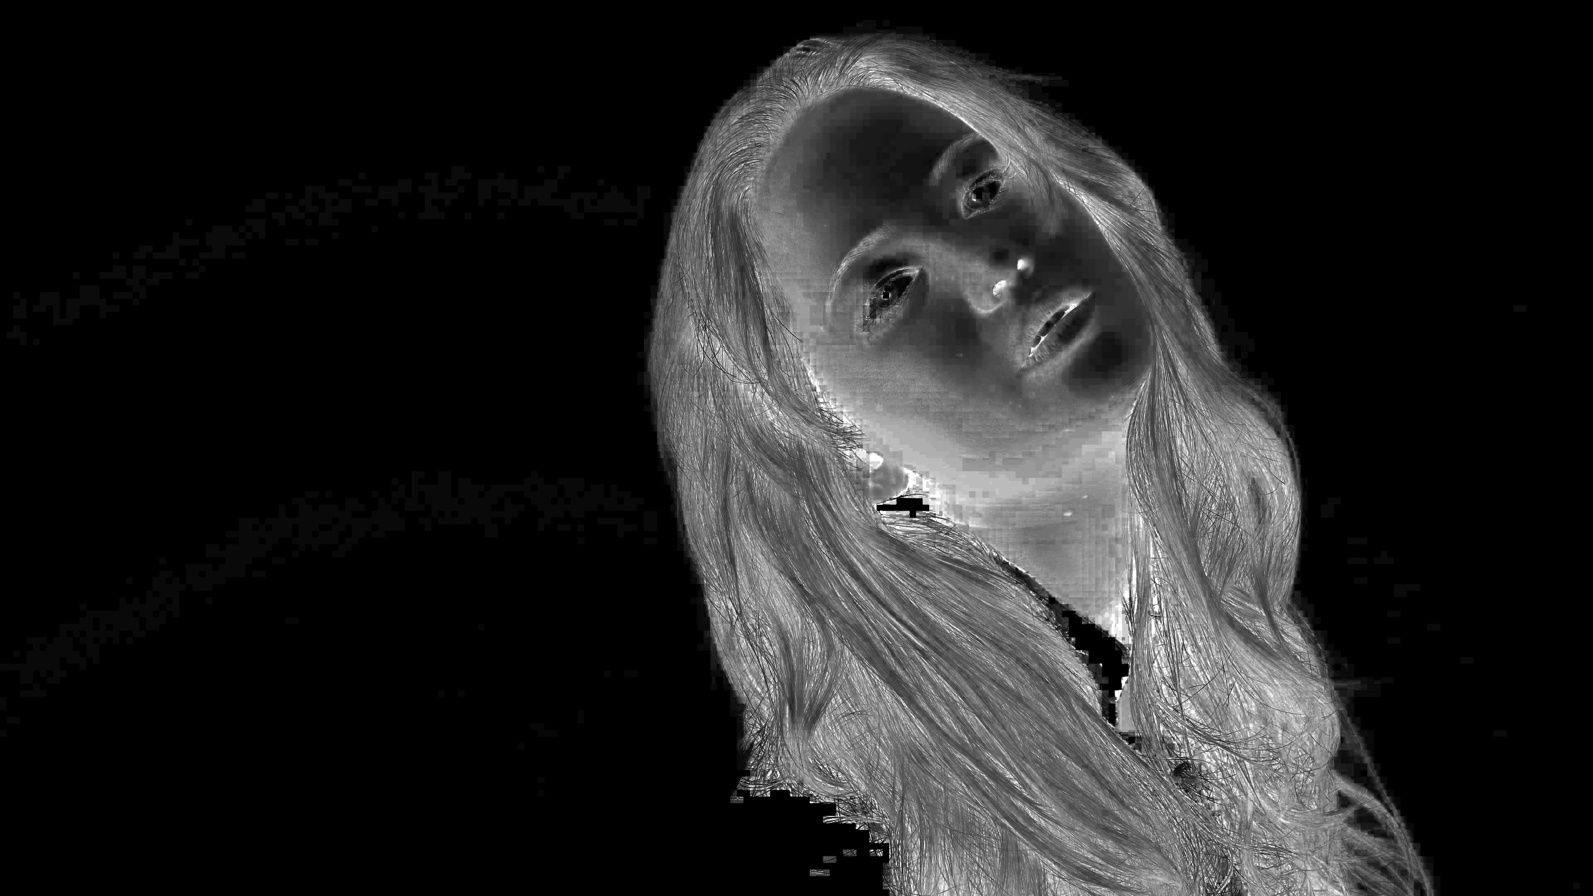 q5_v** 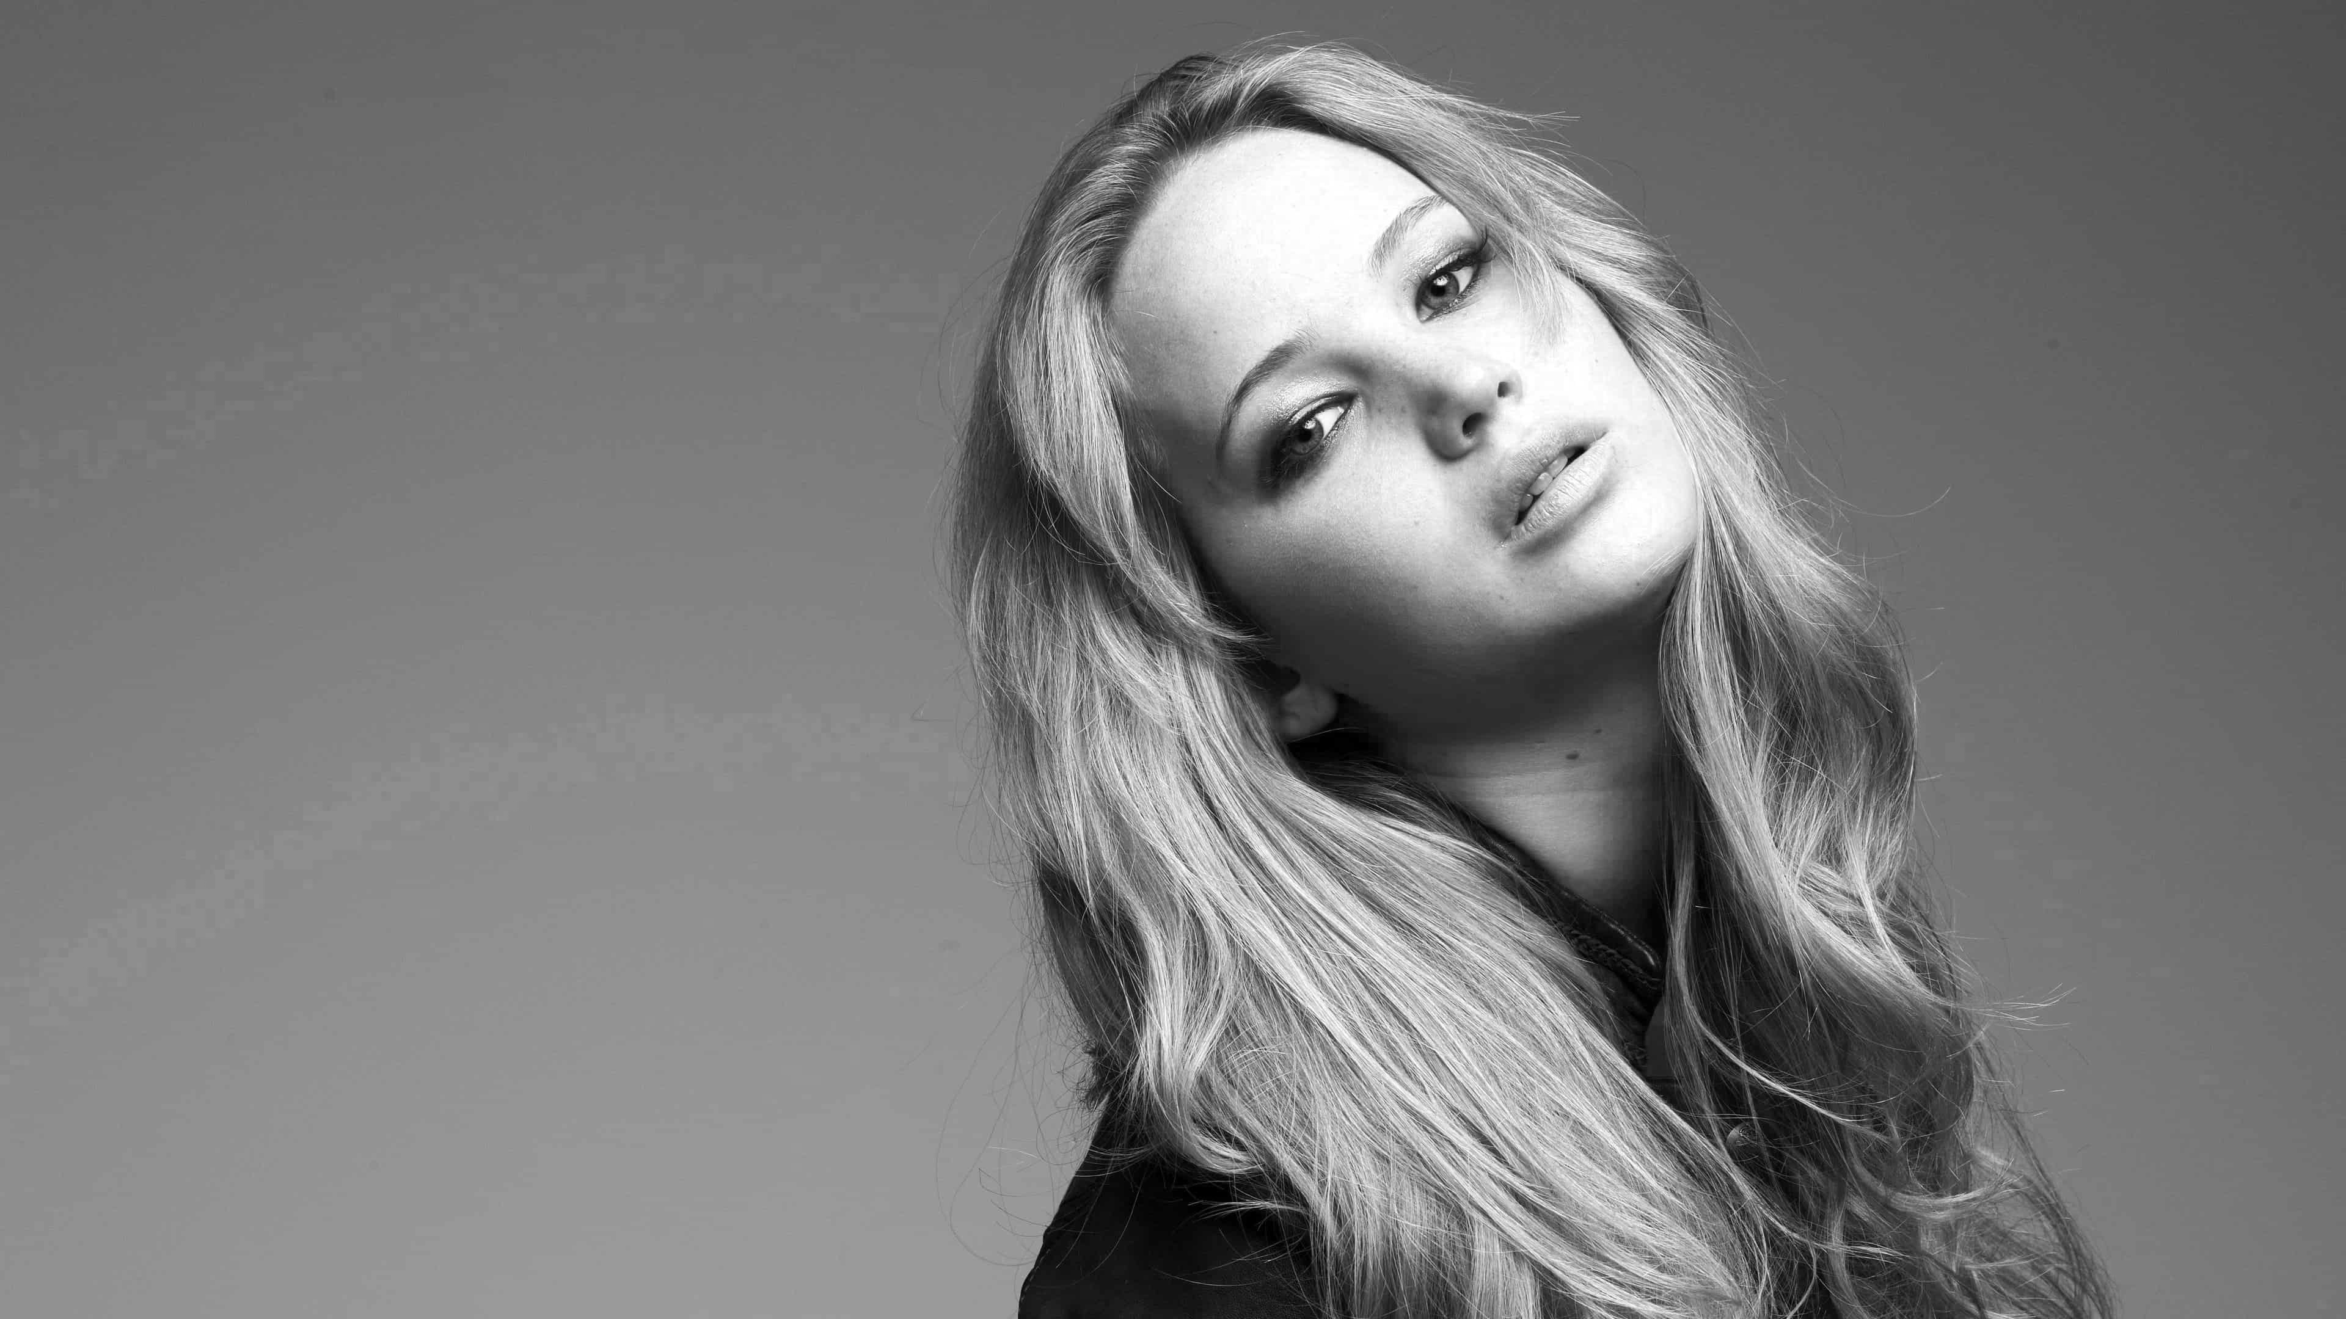

**q5_mask 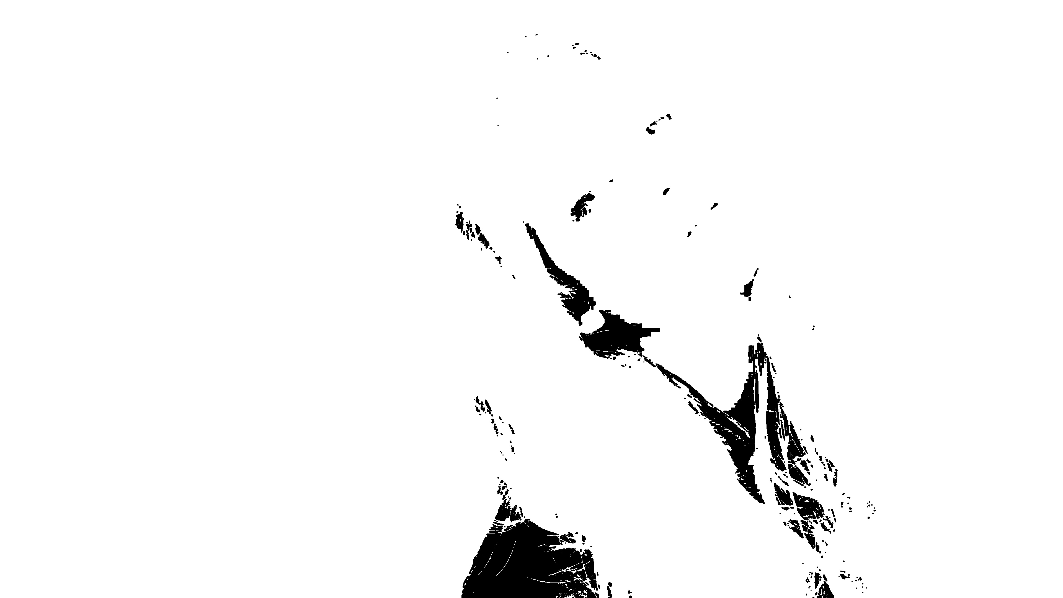 q5_result** 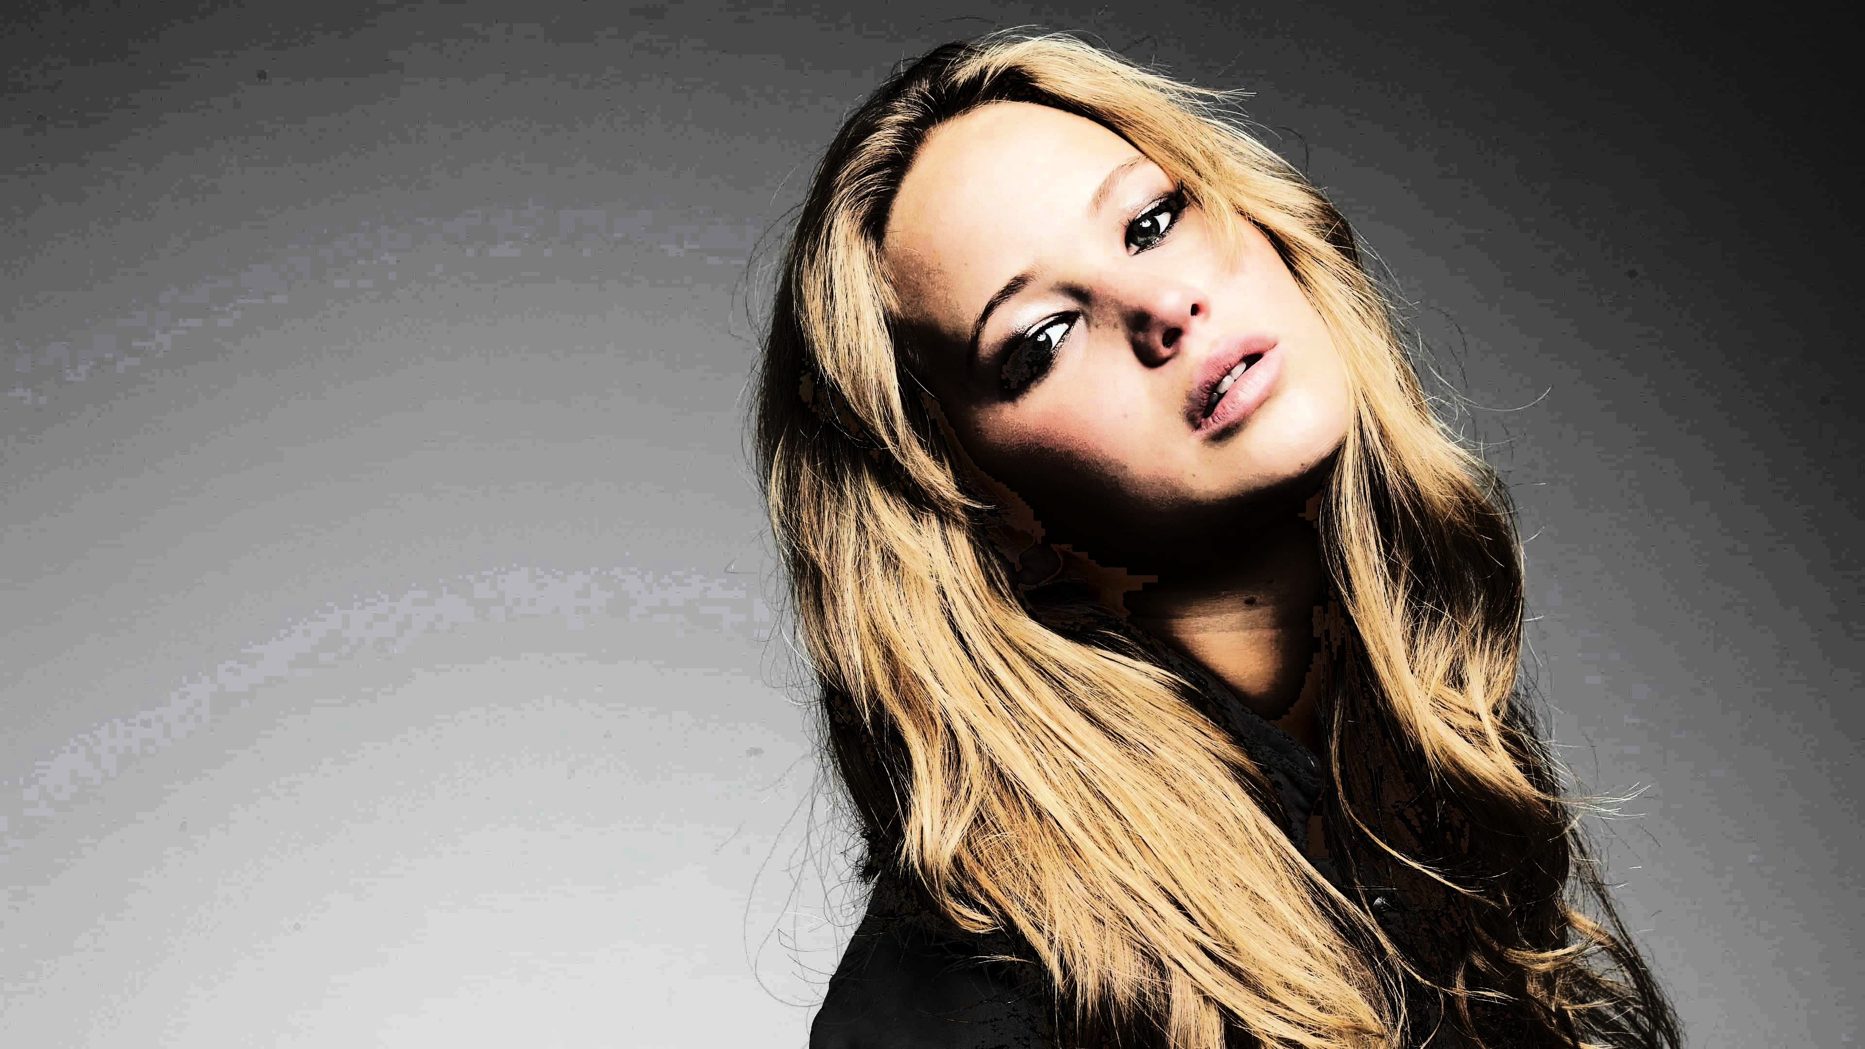

# Question 6: [Code for q6](https://github.com/harithushan/intensity_transformations_and_neighborhood_filtering/blob/main/q6.py)

**q6_orig 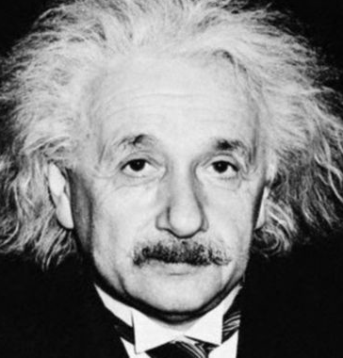 q6_a_mag** 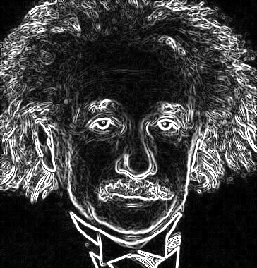

**q6_b_mag**  **q6_c_mag** 

# Question 7: [Code for q7](https://github.com/harithushan/intensity_transformations_and_neighborhood_filtering/blob/main/q7.py)

**q7_pair1_blx4**  **q7_pair1_large** 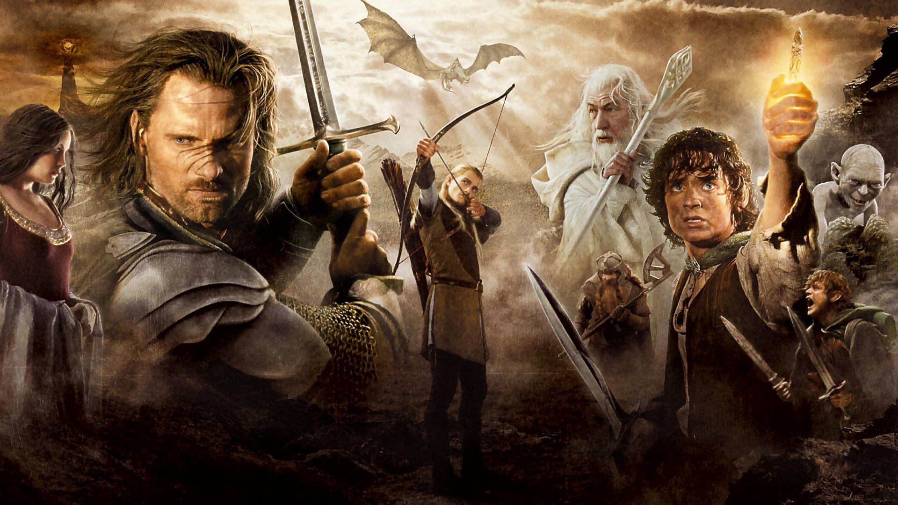

**q7_pair1_nnx4** 

**q7_pair2_blx4 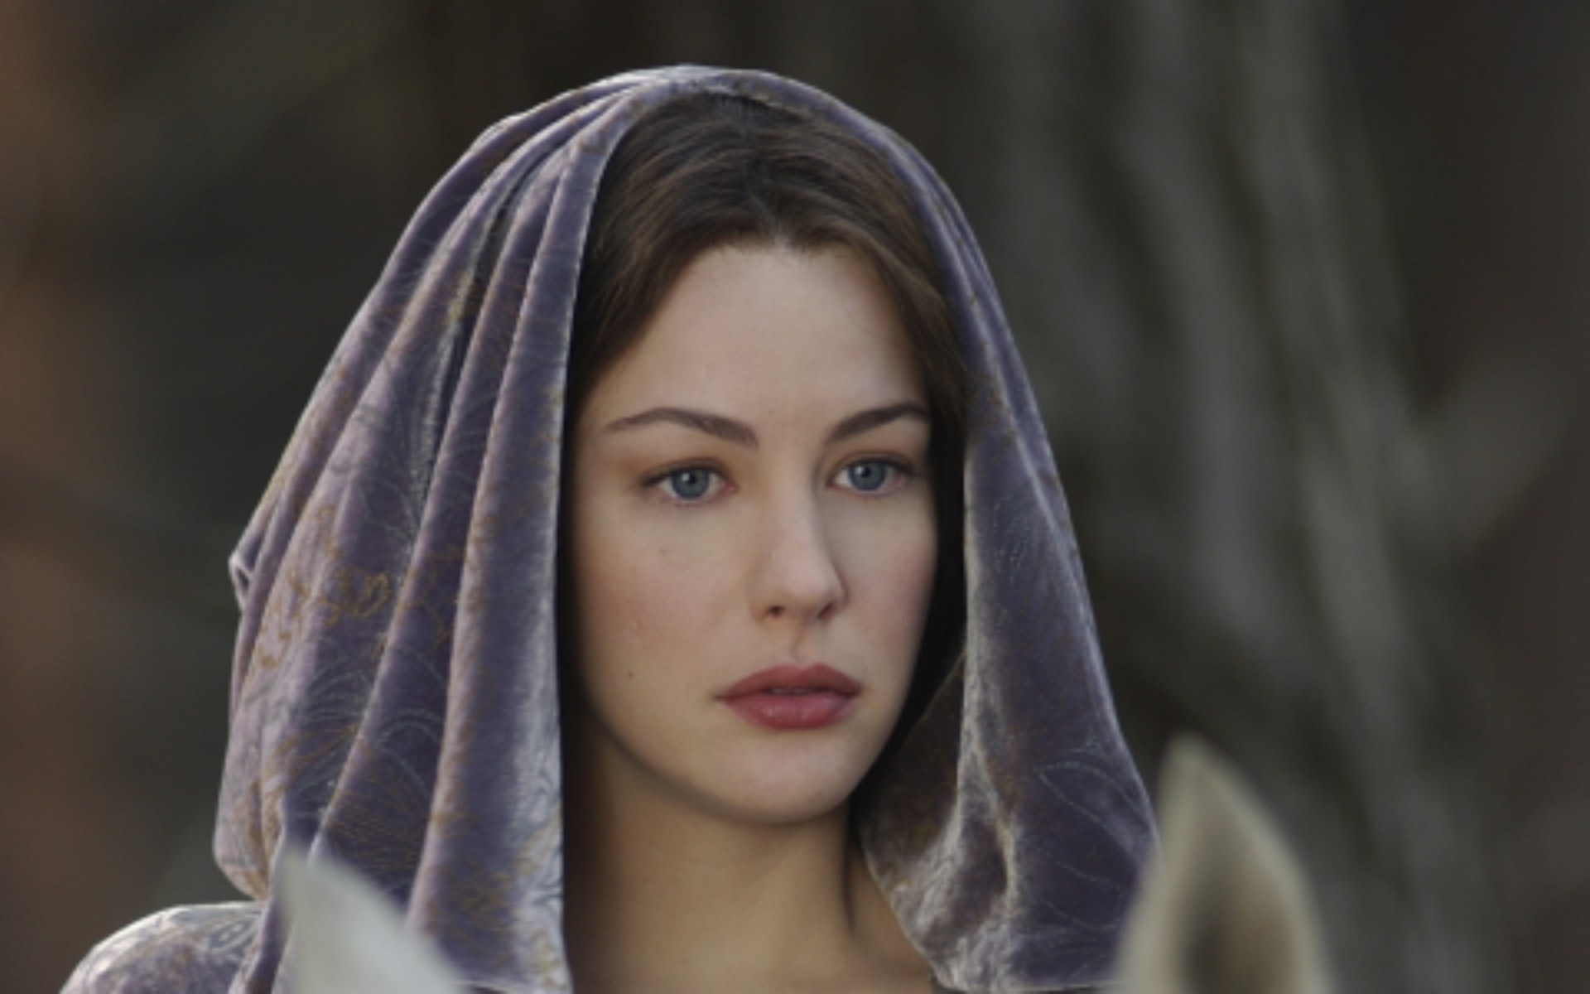 q7_pair2_large** 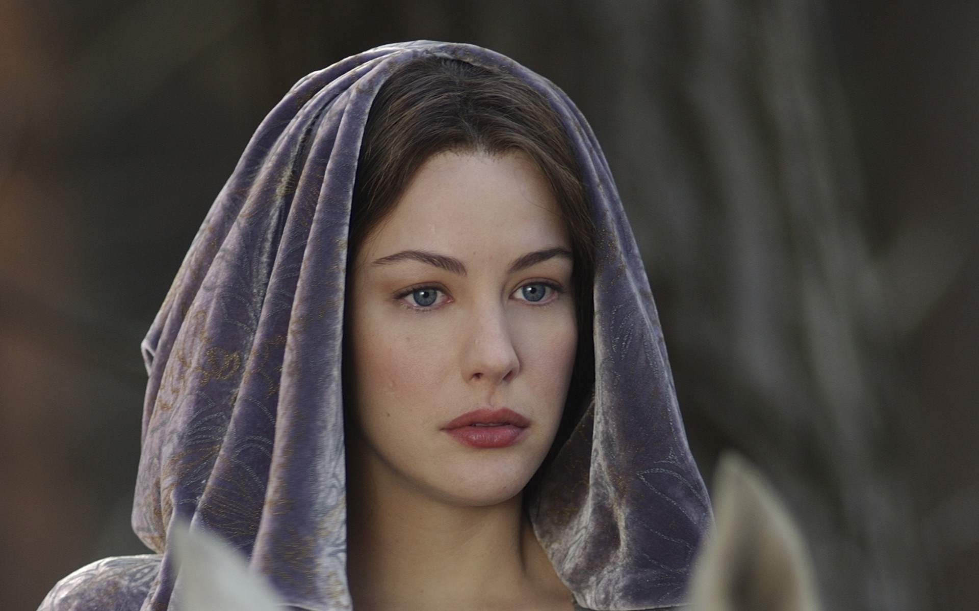

**q7_pair2_nnx4** 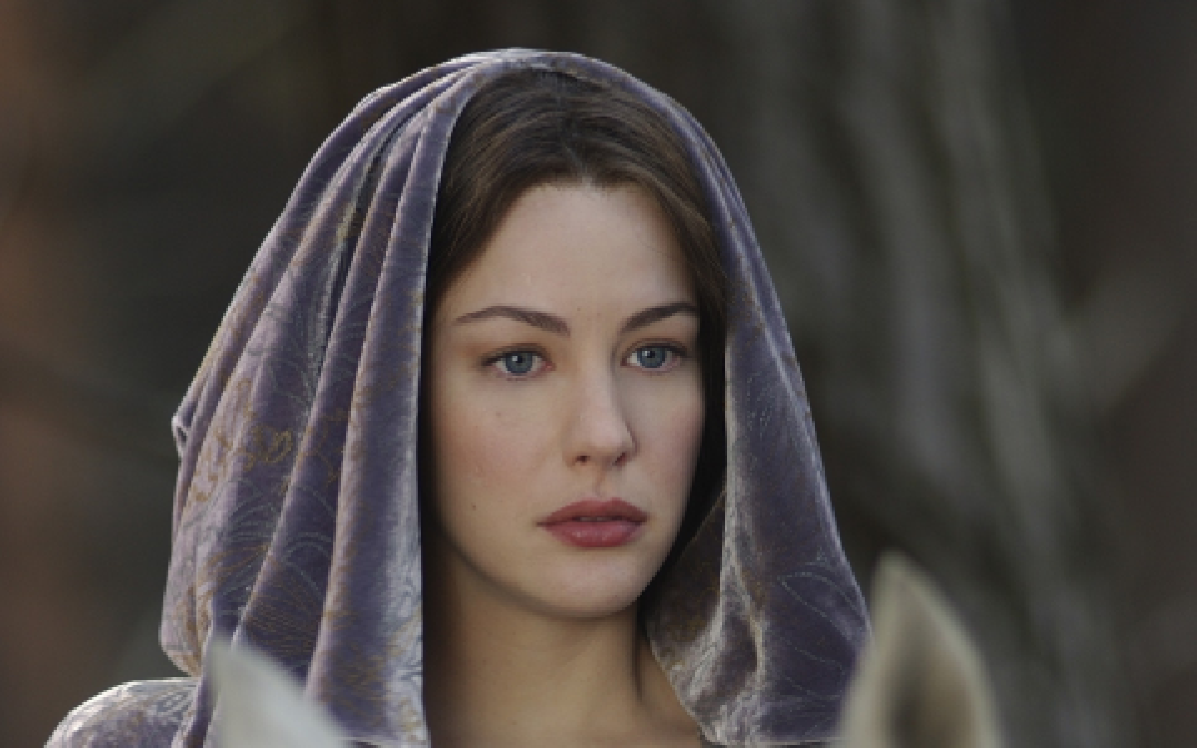

**q7_pair3_blx4 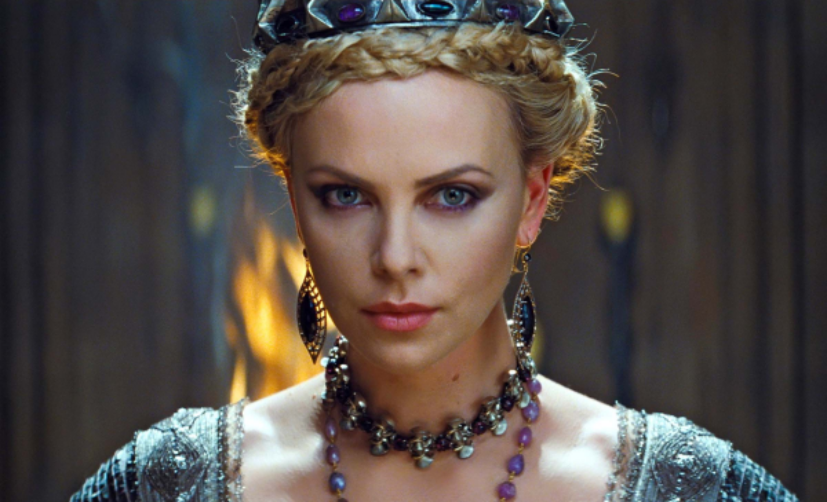 q7_pair3_large** 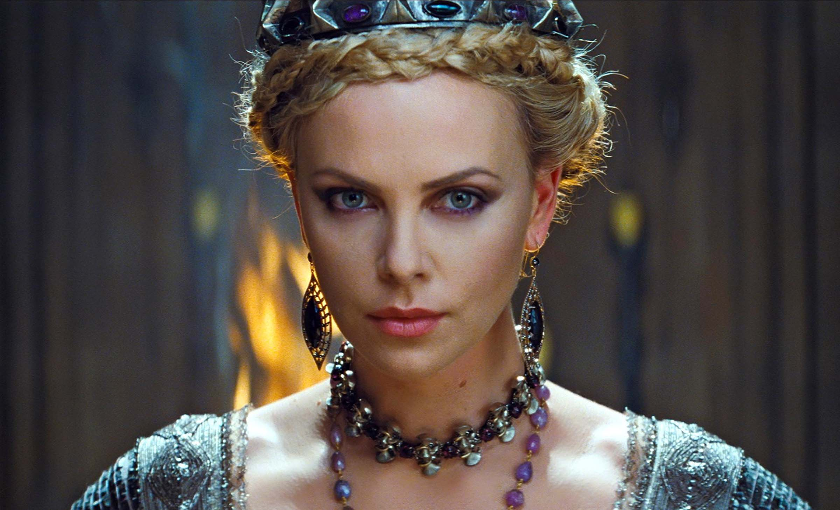

**q7_pair3_nnx4** 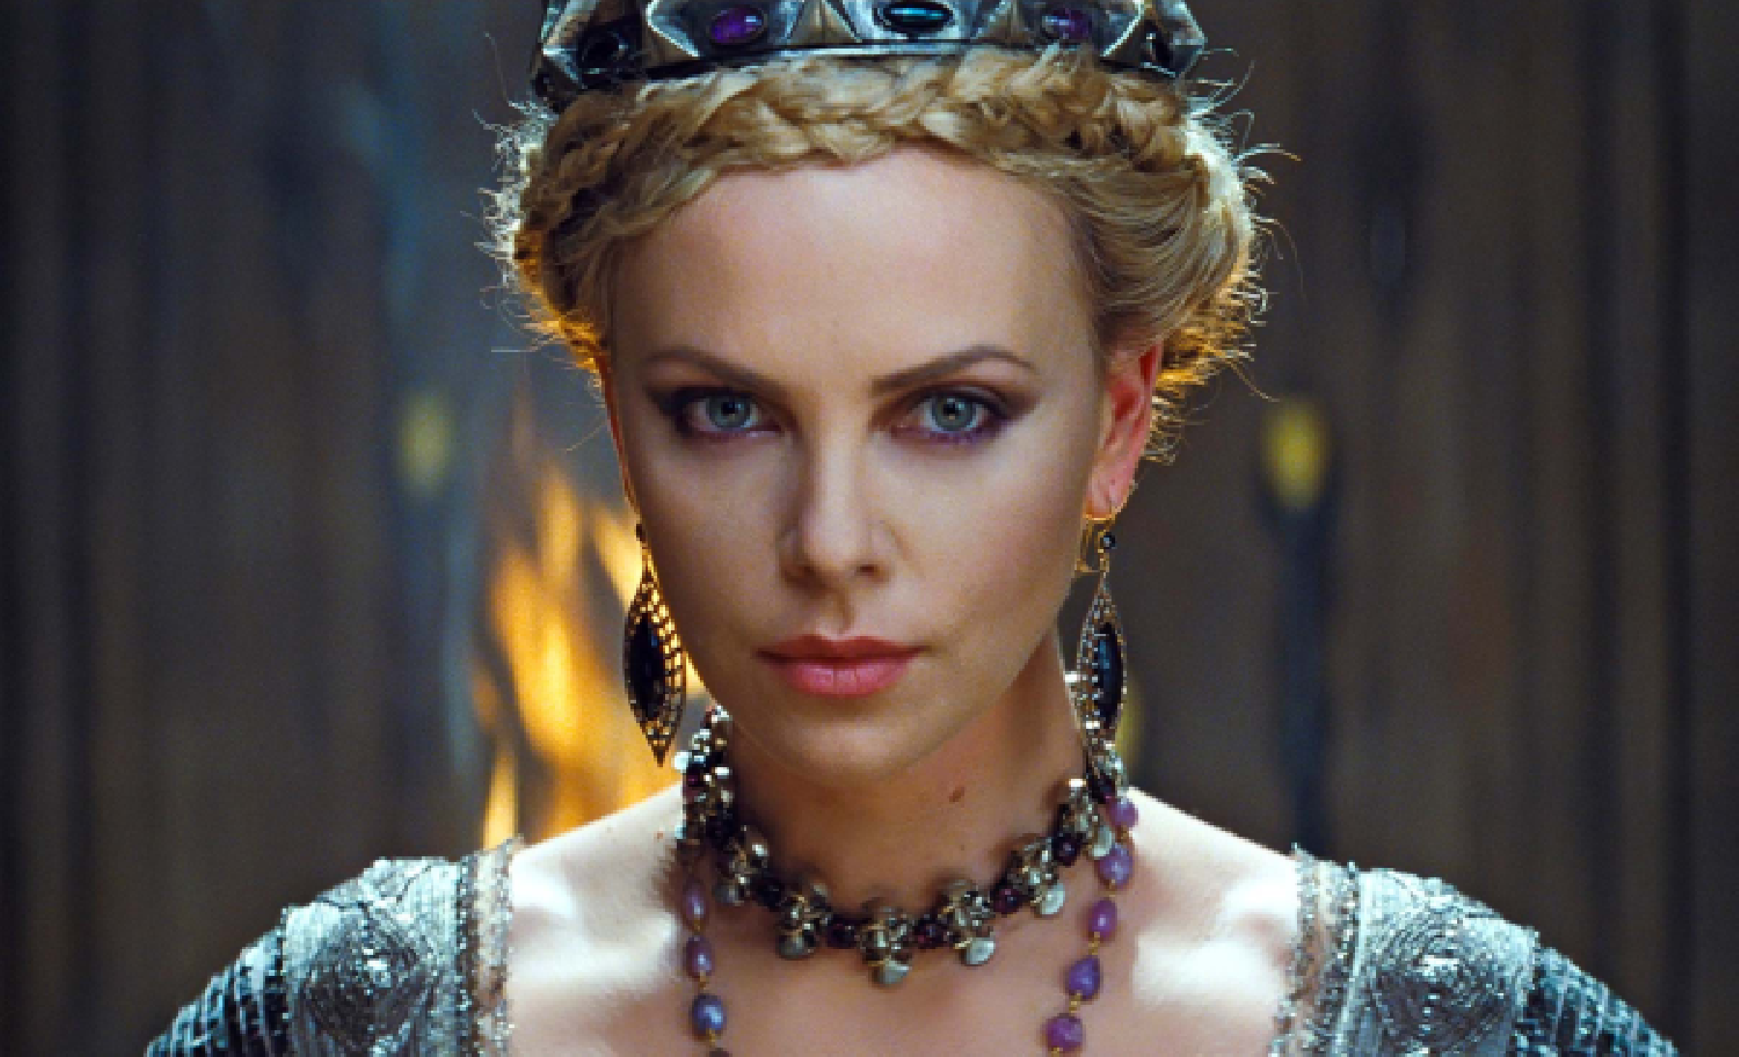

**q7_pair4_blx4**  **q7_pair4_large** 

**q7_pair4_nnx4**  **q7_pair5_blx4** 

**q7_pair5_large**  **q7_pair5_nnx4** 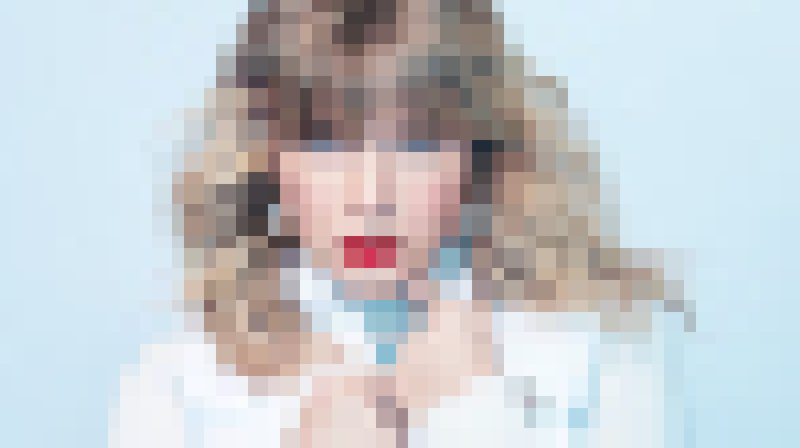

| **Image Pair** | **SSD (Nearest Neighbor)** | **SSD (Bilinear)** |
| --- | --- | --- |
| pair1 | 0.02259 | 0.01019 |
| pair2 | 0.01024 | 0.00291 |
| pair3 | 0.01472 | 0.00568 |
| pair4 | 0.00686 | 0.00527 |
| pair5 | 0.01579 | 0.01062 |

# Question 8: [Code for q8](https://github.com/harithushan/intensity_transformations_and_neighborhood_filtering/blob/main/q8.py)

**q8_original 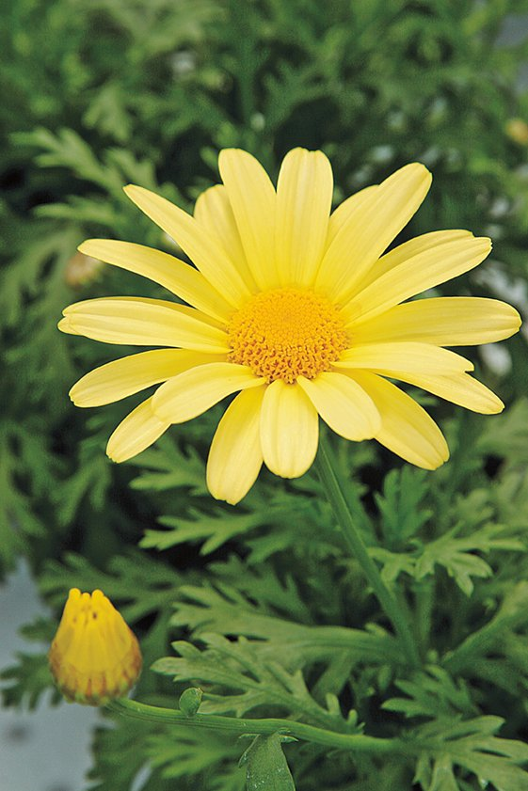 q8_fg 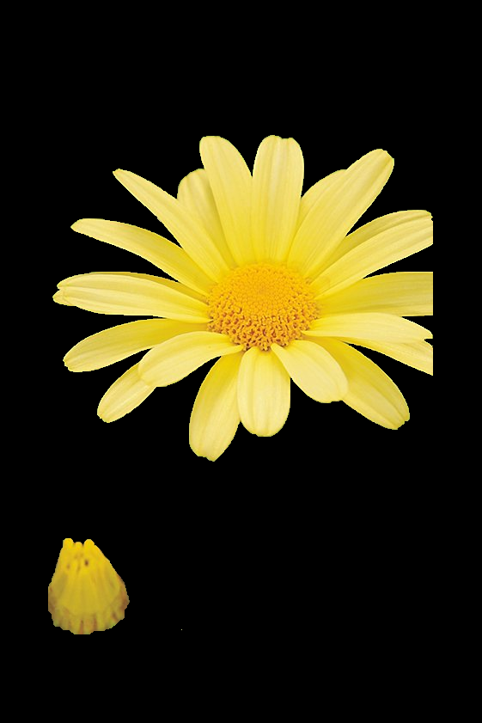 q8_mask** 

Dark rim occurs due to uncertain boundary labeling and blur mixing darker background near edges.

**q8_bg 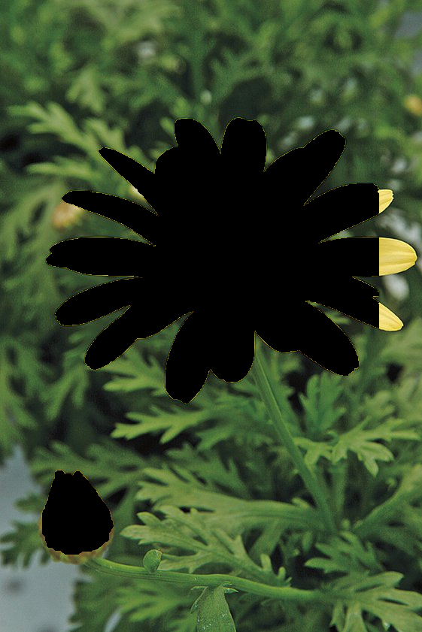 q8_enhanced** 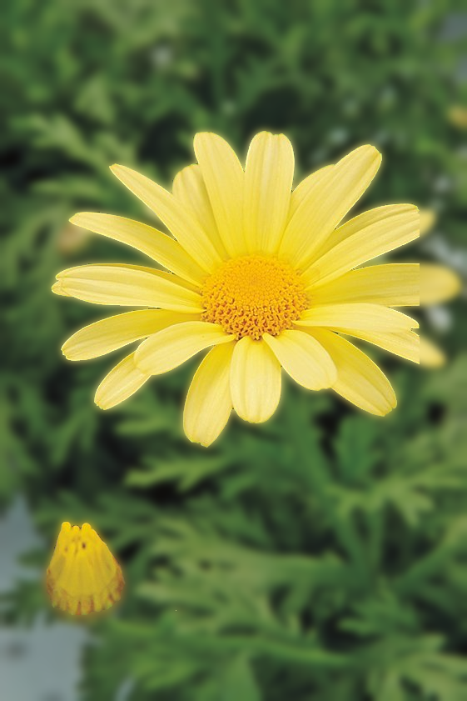

# Question 9: [Code for q9](https://github.com/harithushan/intensity_transformations_and_neighborhood_filtering/blob/main/q9.py)

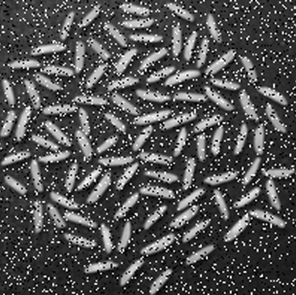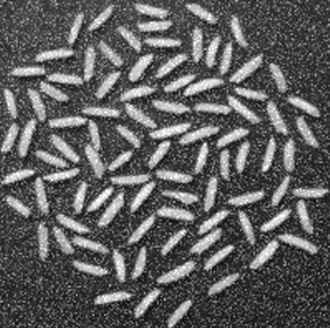

**q9_gauss_clean 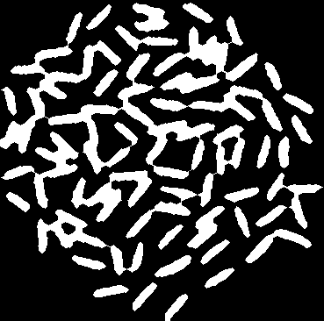 q9_gauss_den 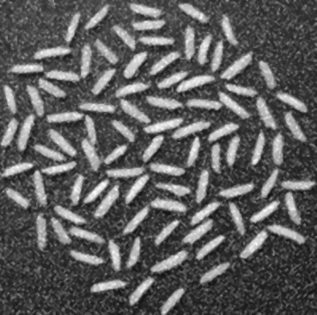 q9_gauss_th** 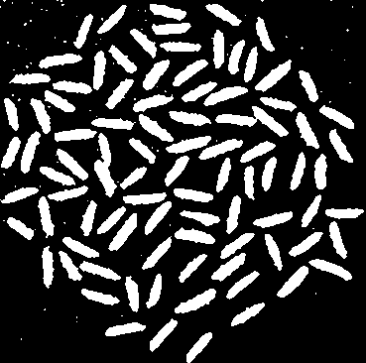

**q9_sp_clean 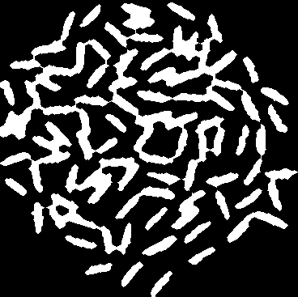 q9_sp_den 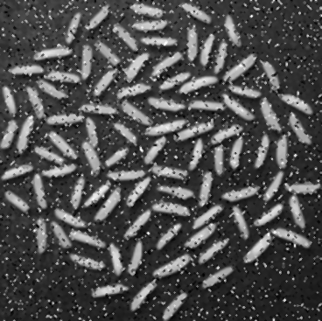 q9_sp_th** 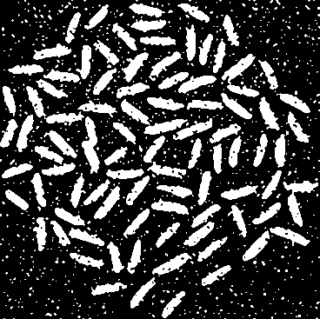

**number of rice grains in Gaussian filter**:36

number of rice grains in **salt-and-pepper noise removal filter**: 35

# Question 10: [Code for q10](https://github.com/harithushan/intensity_transformations_and_neighborhood_filtering/blob/main/q10.py)

**q10_original 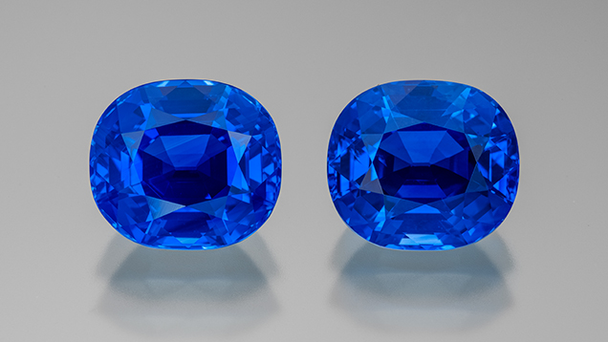 q10_mask** 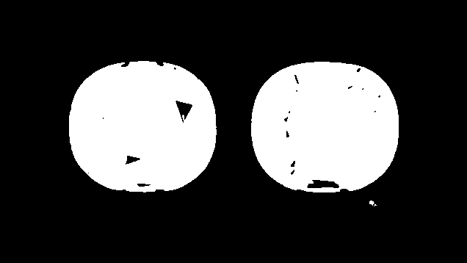

| **Sapphire** | **Area (mm²)** |
| --- | --- |
| 1 | 1,710.8 |
| 2 | 1,719.0 |

**q10_filled** 